 

GRACE COLLEGE OF ENGINEERING

Department of Artificial Intelligence and Data Science

Title:

Laptop Request Catalog Item

| **Submitted to:**  Mrs N. Nancy Chitra Thilaga M.E, Assistant Professor | **Submitted by**  R. Alex Matthew (950322243001)  J. Felix Silvan (950322243005)  Oshan Abdul Haque (950322243018) |
| --- | --- |

# ABSTRACT

The *Laptop Request Catalog Item* project was developed within the ServiceNow platform to streamline the process of requesting laptops through the organization’s Service Catalog. The project demonstrates the configuration and customization of a catalog item that allows end users to submit laptop requests with predefined input variables such as laptop model, justification, and delivery location.

This implementation begins with the creation of a **Local Update Set** to capture and manage all configuration changes made during the development process. Following that, a **Service Catalog Item** titled *Laptop Request* was created under the Hardware category to represent the request form accessible to users. Within this catalog item, multiple **variables** were defined to collect user-specific information required for processing laptop requests efficiently.

To ensure a user-friendly and rule-driven experience, **UI Policies** and **UI Actions** were applied where necessary, controlling form behavior and enforcing business logic. Once the configuration was completed, the update set was finalized and made ready for export, ensuring that the developed configurations can be easily migrated across different ServiceNow instances.

Finally, comprehensive **testing** was conducted to validate the functionality of the catalog item. The testing process confirmed that the form correctly captured all variables, allowed submission without errors, and created the corresponding request records within ServiceNow.

Overall, this project showcases practical proficiency in configuring catalog items, managing update sets, and applying ServiceNow’s Service Catalog management features. It also highlights an understanding of how ServiceNow can be leveraged to automate and simplify IT service delivery processes such as hardware provisioning. The successful implementation of this catalog item lays the foundation for future enhancements like automated approval workflows, integration with Asset Management, and cost tracking mechanisms.

# INTRODUCTION

This project aims to build a catalog item called **“Laptop Request”** under the hardware category in ServiceNow. Users will be able to request a laptop by filling in required variables (for example: model, justification, delivery location). The item will be captured in an update set so that changes can be transported across instances. The workflow includes: creating a local update set, creating the catalog item, adding variables, applying UI policies/actions, exporting the update set, and testing the item. Documentation from ServiceNow indicates that catalog items built via the Catalog Builder may automatically create update sets. ([ServiceNow](https://www.servicenow.com/community/virtual-agent-forum/update-set-for-new-catalog-item/m-p/3035078?utm_source=chatgpt.com)) Additional guidance on update sets for catalog items is available. ([ServiceNow](https://www.servicenow.com/docs/bundle/zurich-servicenow-platform/page/product/service-catalog-management/task/transfer-catalog-items-using-update-sets.html?utm_source=chatgpt.com))

## TOOLS AND ENVIRONMENT

* ServiceNow Instance: [Insert your instance name]
* Role used: [e.g., admin or catalog_admin]
* Modules used:  
  + System Update Sets → Local Update Sets
  + Service Catalog → Catalog Definitions → Maintain Items
  + Variables (Service Catalog)
  + UI Policy / UI Action (if applicable)
* Purpose: To configure the catalog item such that end‐users can request laptops and the system captures all the necessary information.

## PROCEDURE / STEP-BY-STEP IMPLEMENTATION

### Step 1: Create Local Update Set

**Description**: Navigate to *System Update Sets → Local Update Sets*, click **New**, give it a meaningful name (e.g., “Laptop Request Catalog Item Update Set”), set it as current.  
 **Screenshot**: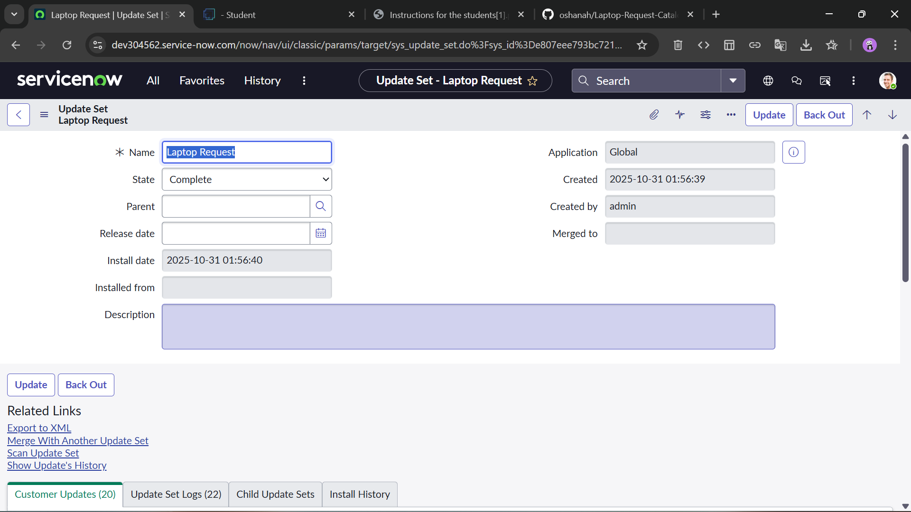  
 **Remarks**: This ensures that all subsequent configuration changes are captured in the update set for transport.

### Step 2: Create Service Catalog Item

**Description**: Go to *Service Catalog → Catalog Definitions → Maintain Items*. Click **New**, select the **Hardware** category, name the item “Laptop Request”, fill in short description, description, icon if needed, and save.  
 **Screenshot**: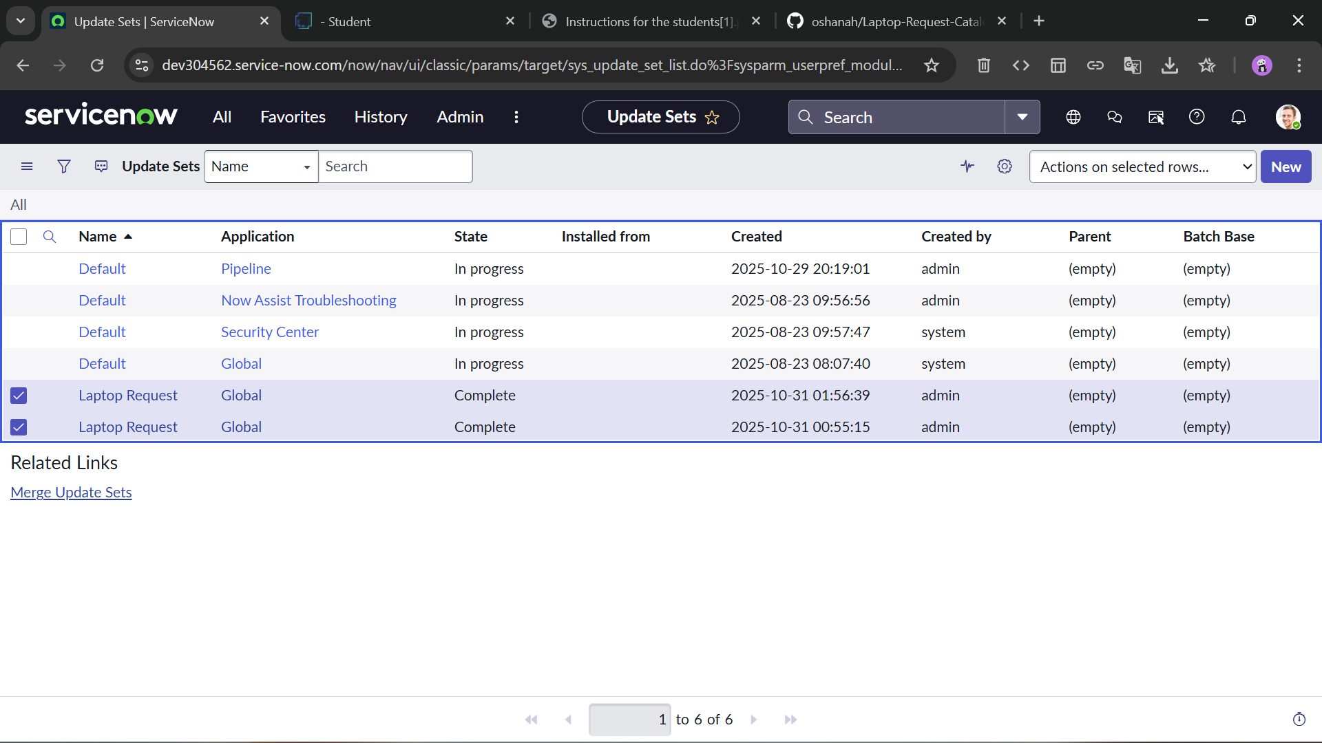  
 **Remarks**: Category alignment ensures users find the item under hardware requests.

### Step 3: Add Variables

**Description**: In the catalog item record, navigate to the Variables related list. Add the required variables (for example:

* Model (Dropdown)
* Justification (Multi-line text)
* Delivery Location (Reference to Location table)  
   )  
   For each variable, set question text, type, order, related table if needed.

**Screenshot**: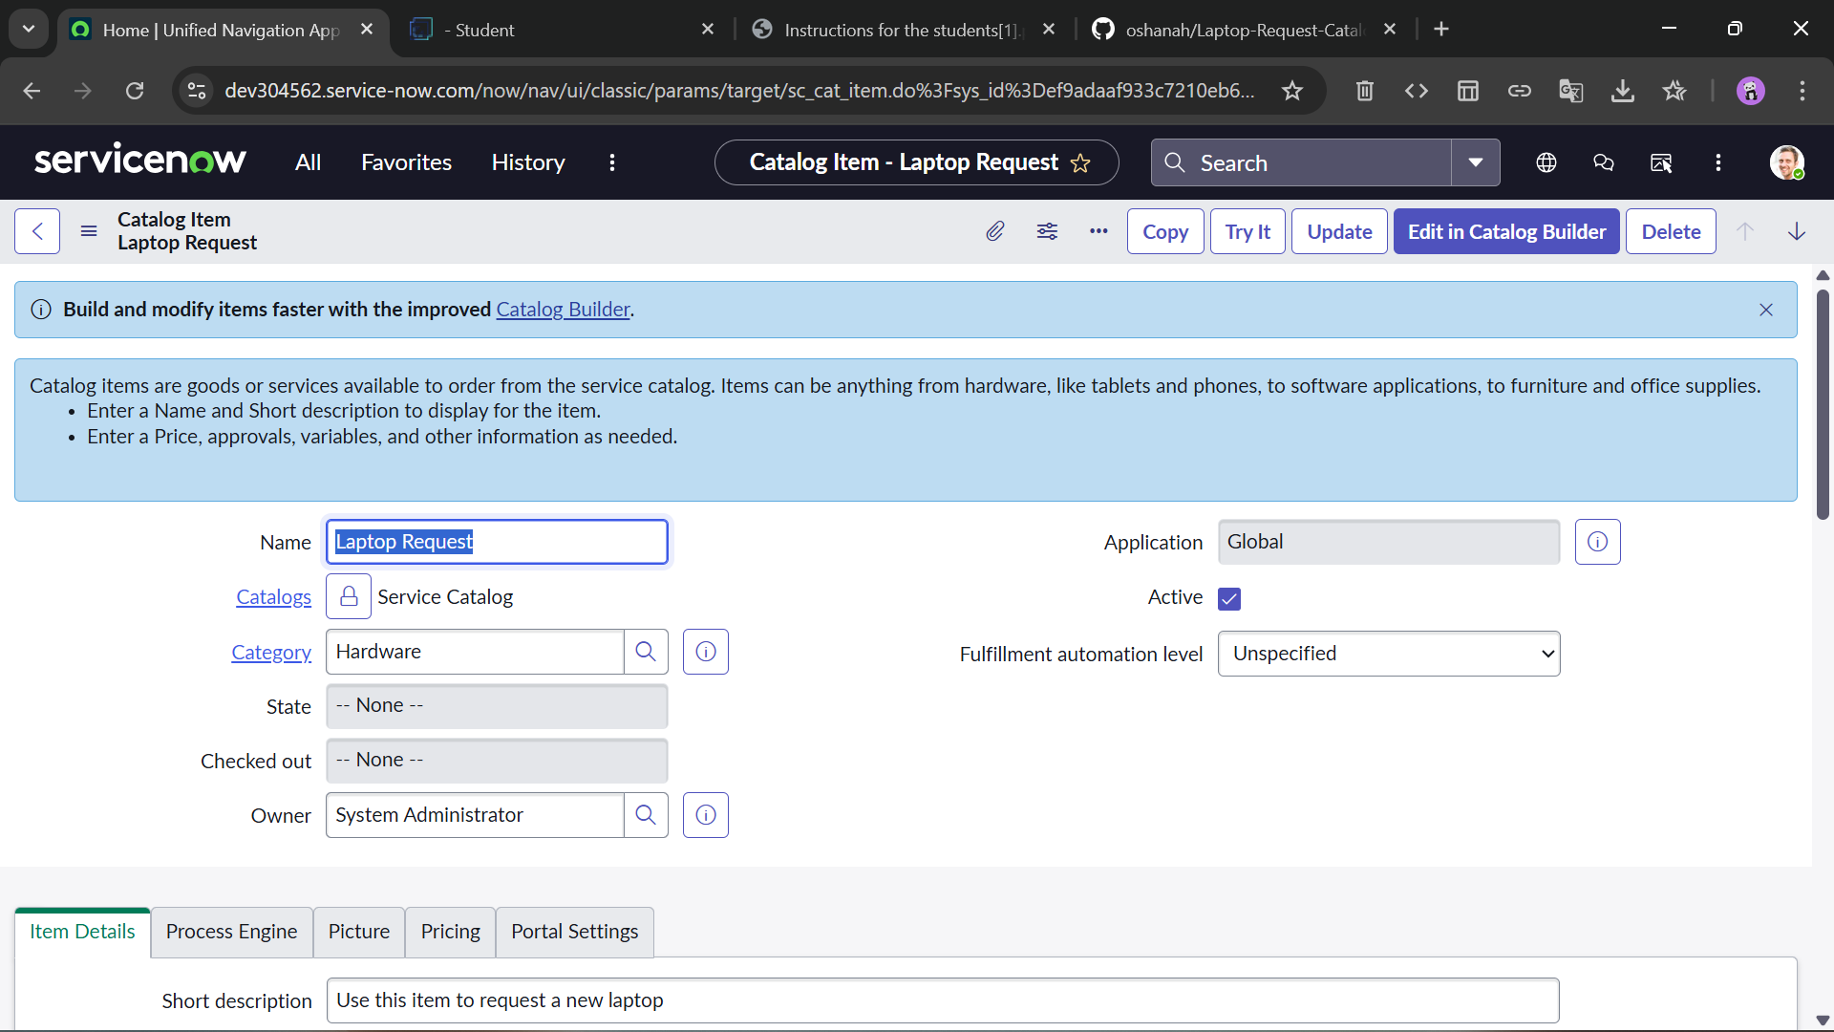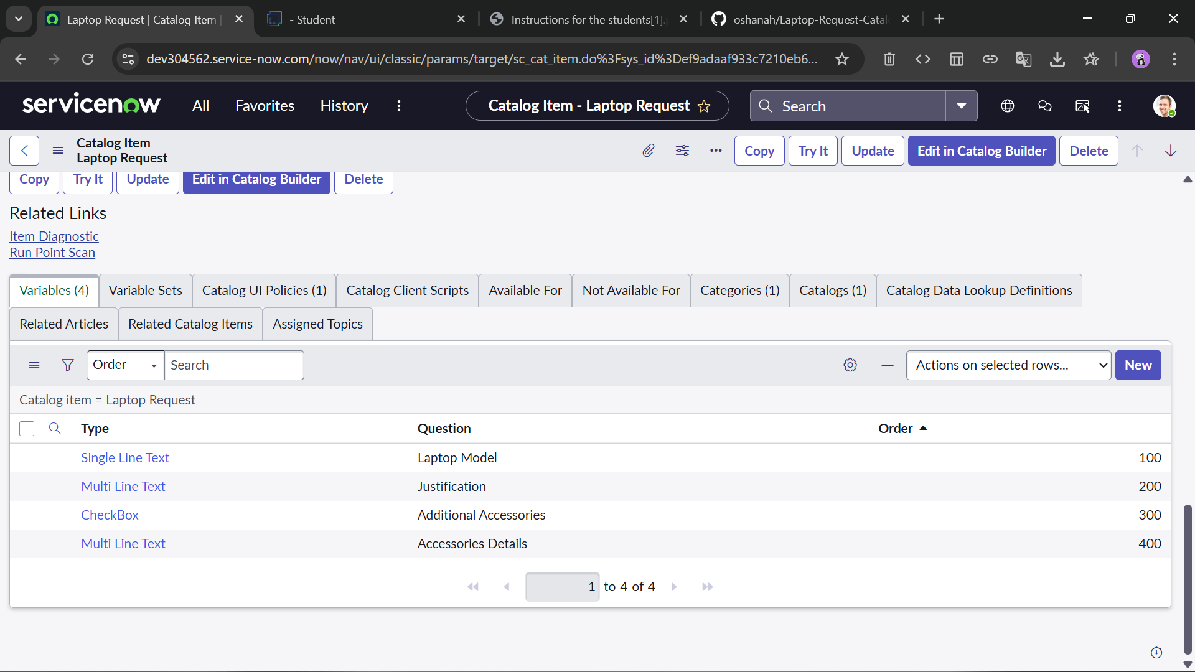

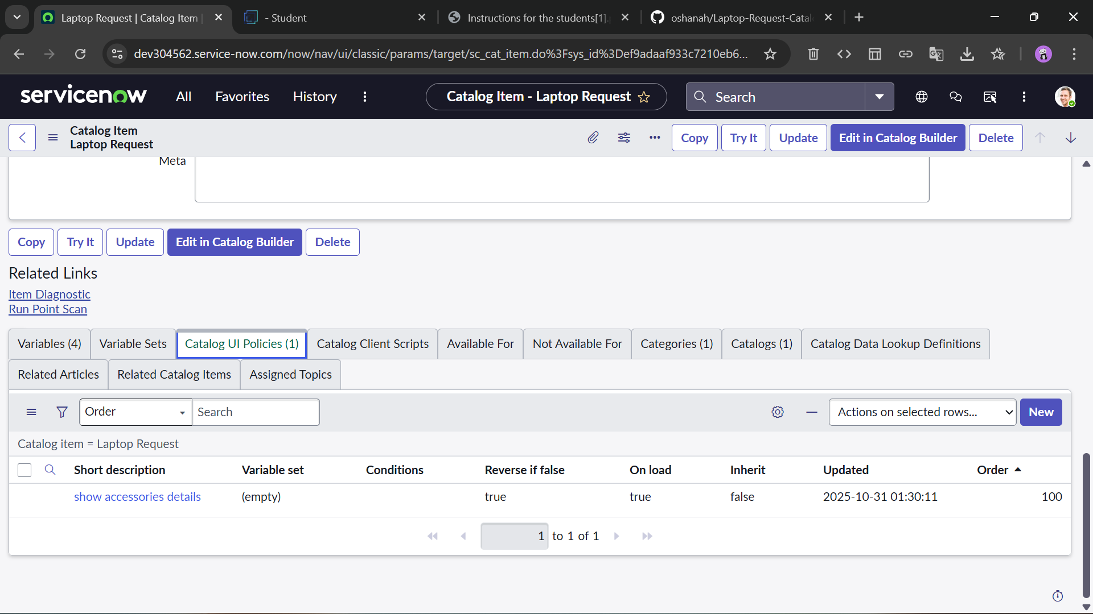  
 **Remarks**: Variables provide input fields for the requester to capture necessary information.

### Step 4: Create UI Policy / UI Action (if applicable)

**Description**: If you want to enforce rules (e.g., if justification is blank then disable submit) you can configure a UI Policy: *Service Catalog → Variables → UI Policies*. Set conditions and actions. Similarly for UI Action if any custom button is needed.  
 **Screenshot**: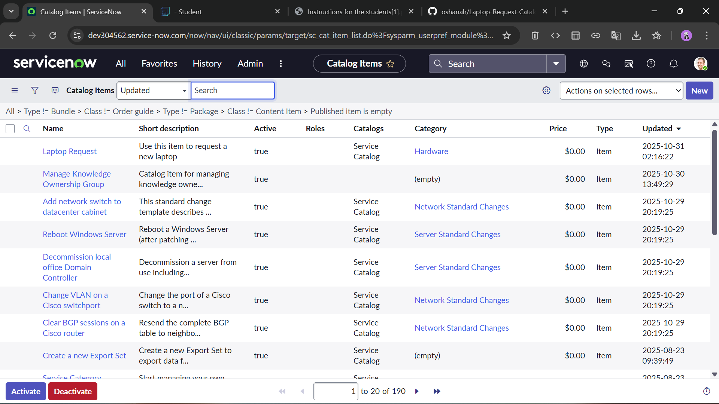  
 **Remarks**: UI Policies improve user experience and enforce business logic at the form level.

### Step 5: Preview/Export Update Set

**Description**: Once configuration is done, go back to the update set created in Step 1, mark it **Complete**, and then if needed export it as XML for use in other instances.  
 **Screenshot**: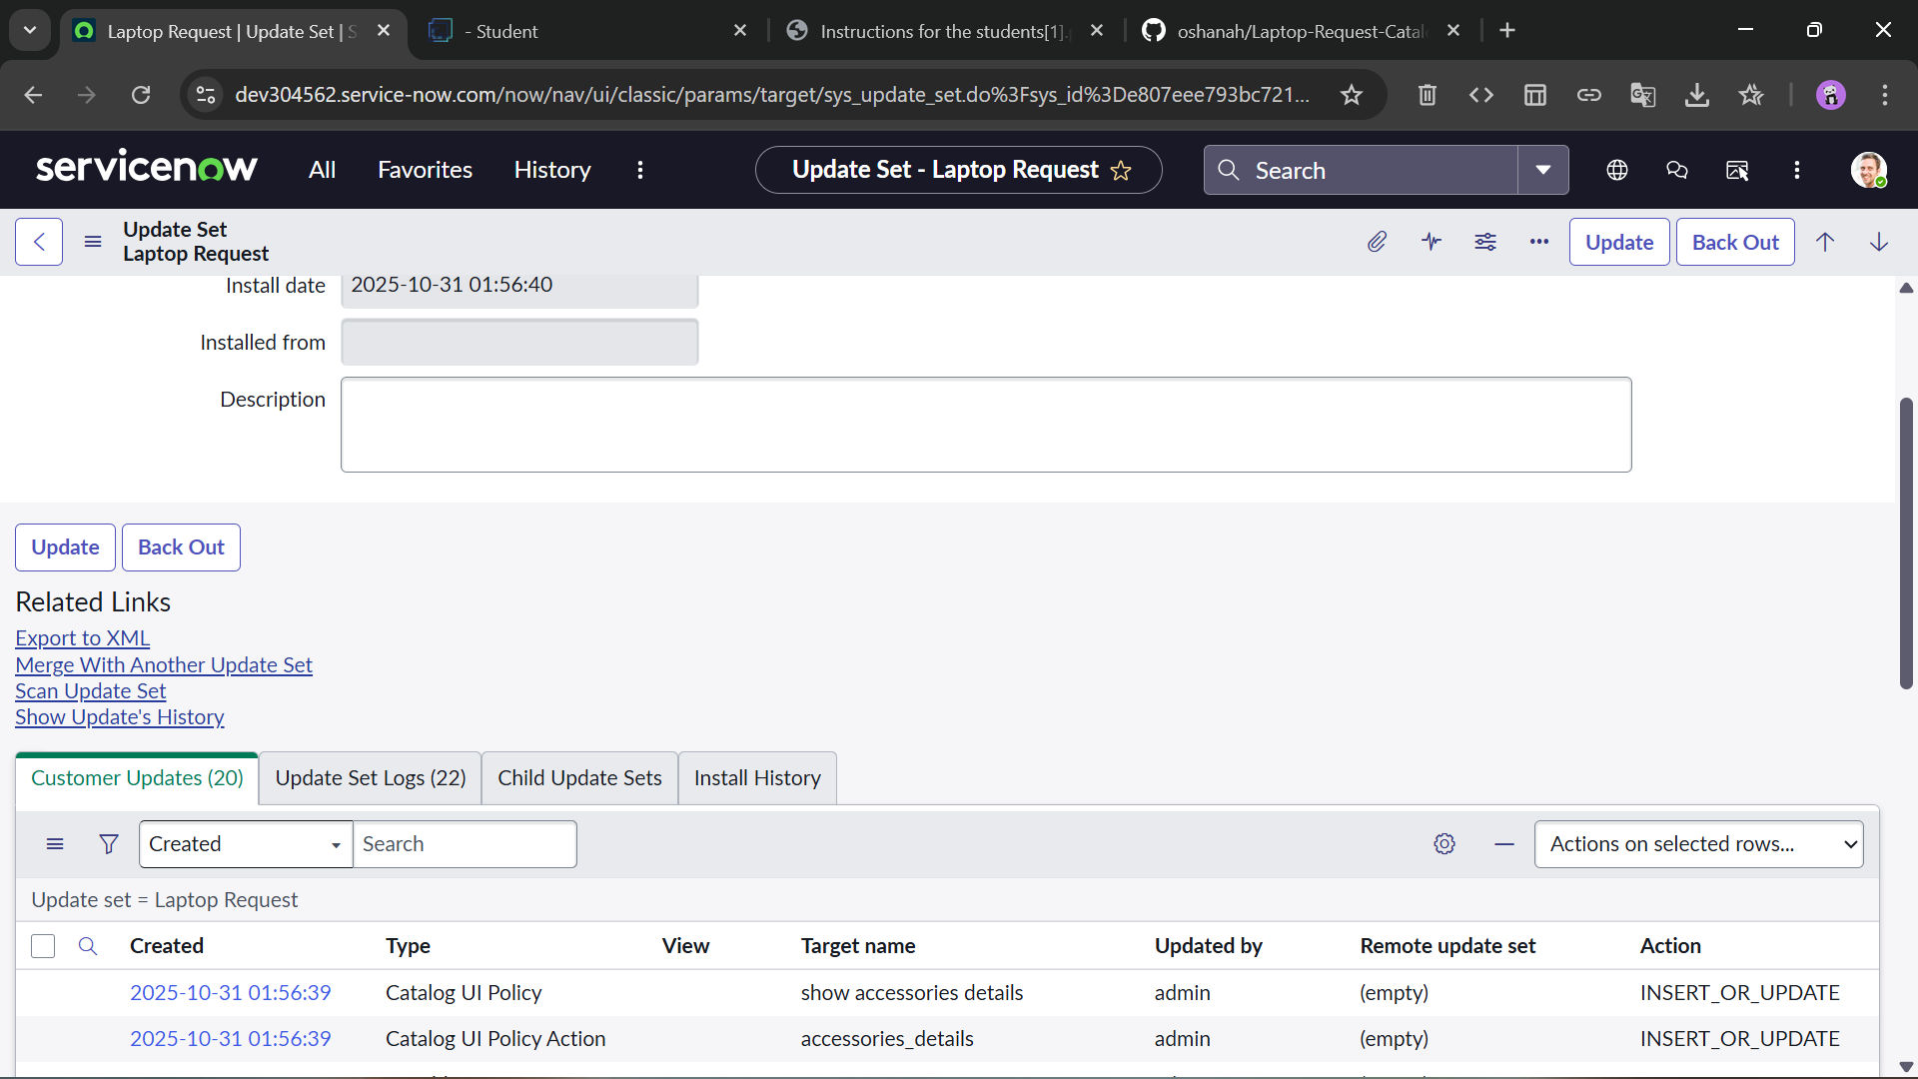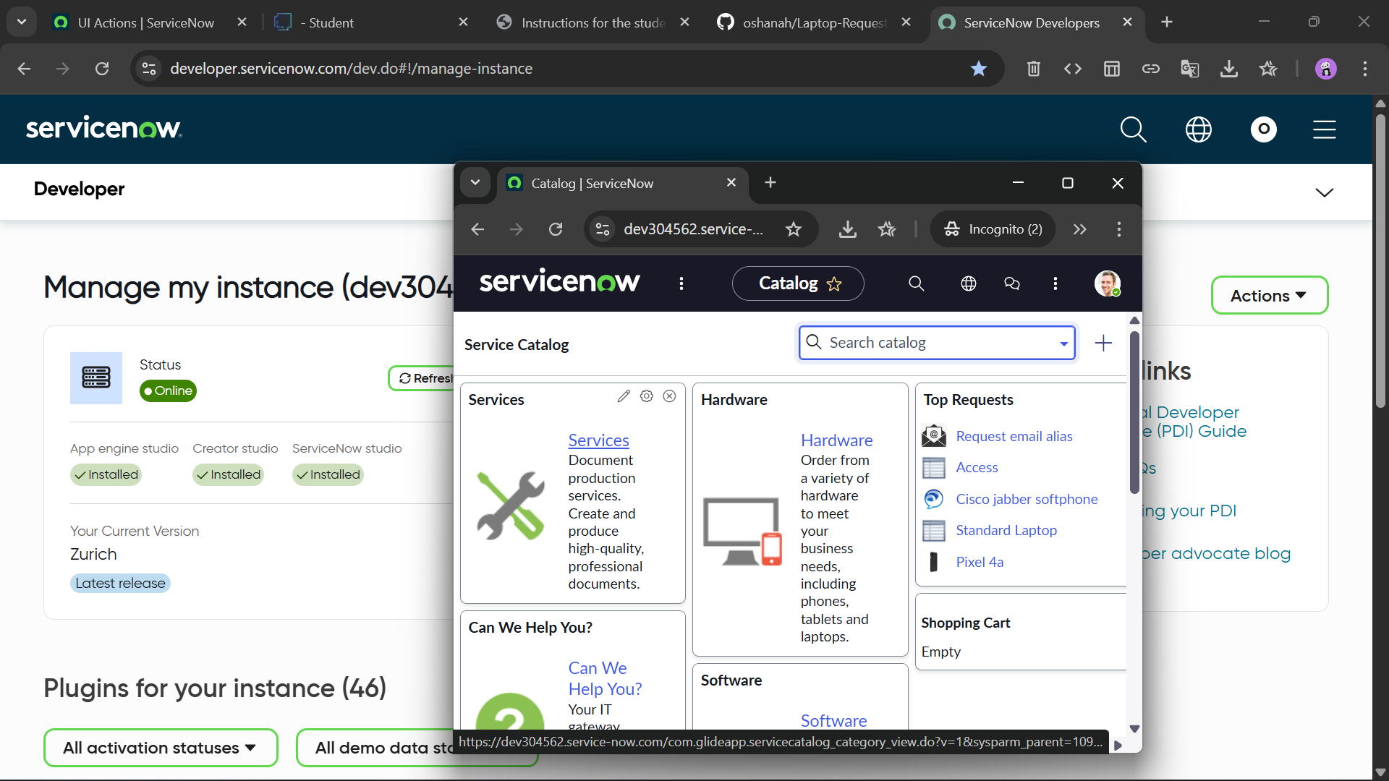  
 **Remarks**: A completed update set ensures that the changes are committed and available for migration.

### Step 6: Test Catalog Item

**Description**: Navigate to *Service Catalog* or the portal, locate “Laptop Request” under Hardware category. Fill in the variables, submit the request. Verify that the request is created (e.g., a Request or RITM record). Check that variables captured in record.  
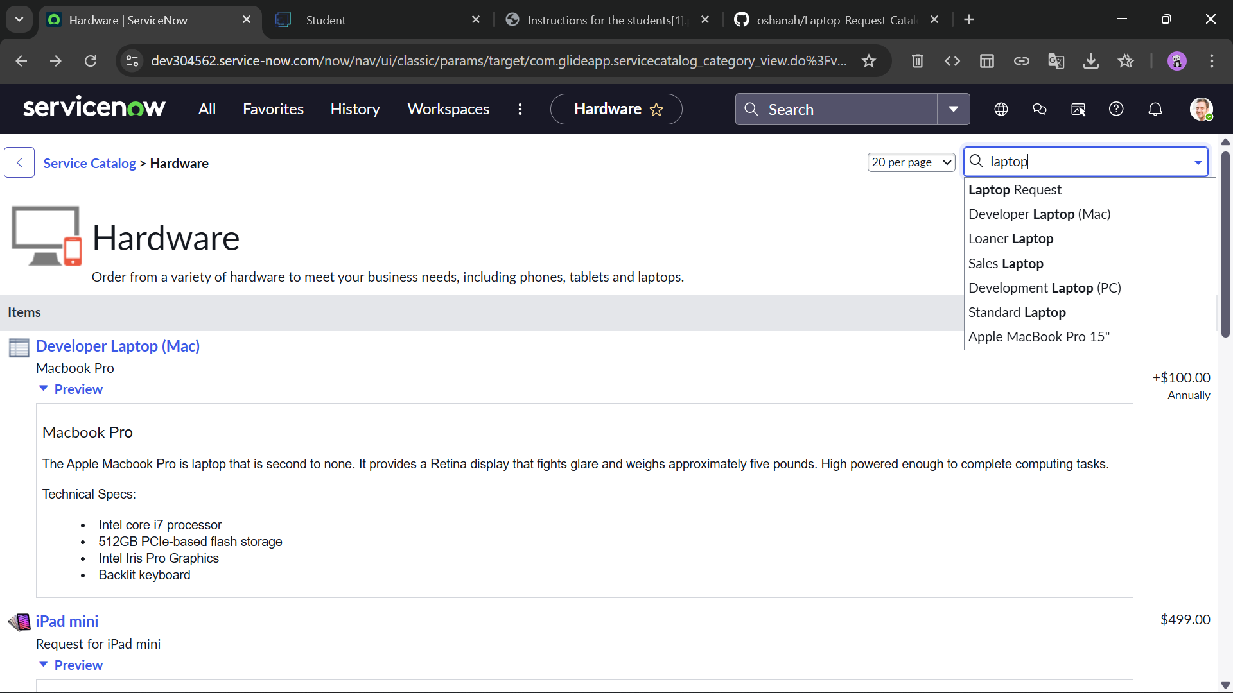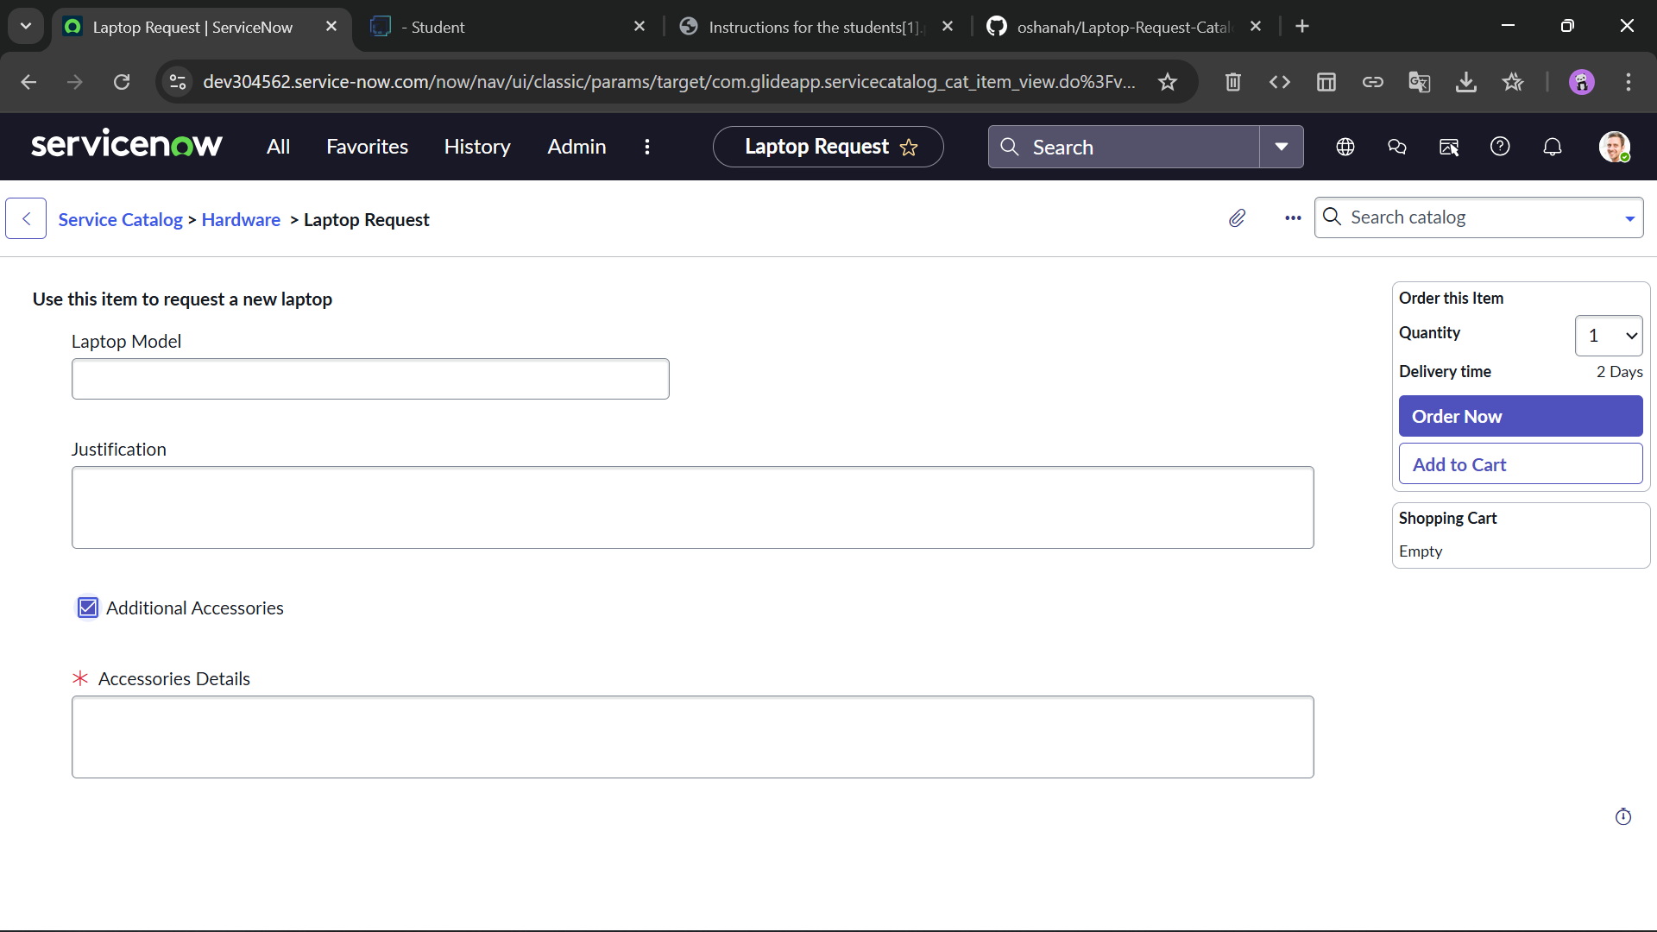  
 **Remarks**: End-to-end testing ensures functionality works from user request to system creation.

## RESULTS / OBSERVATIONS

* The “Laptop Request” catalog item appears correctly under the Hardware category.
* The variables are displayed as expected and input values are captured.
* The update set captured the configuration changes for the catalog item.
* Upon submission, the request is logged and variables persist in the task record.
* Any UI Policy logic (if implemented) triggered appropriately (e.g., requirement check).
* No error messages encountered during testing.

## CONCLUSION

In this project, I successfully created a catalog item “Laptop Request” in ServiceNow, configured variables for user input, implemented UI logic, and captured all configuration in an update set. The item is live and functional from the user-request perspective. This enables users to request laptops via the service catalog, and the setup is transportable via update sets. Going forward, additional enhancements could include approval workflows, cost tracking, integration with asset management, and improved user criteria for availability.

# OUTPUT LINKS

Drive Video Link: <https://drive.google.com/file/d/1O_1b6JmT7uLcrMyQvjffbBgAu_HZgzTj/view>

GitHub Link:

<https://github.com/oshanah/Laptop-Request-Catalog-Item.git>

Drive folder Link:

<https://drive.google.com/drive/folders/1eGBlQqibSHZsCdJC4OYmT5EISDvNwQwF?usp=sharing>